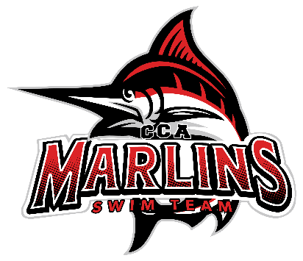

Marlins Board Meeting Minutes (11/19/25)
Attendees: Whitney, Julie, Ginger (Special Guest), Coach Kevin, Coach Jamie, Coach Amina, Coach Susan, Coach Buffy, Juliet, Brooke
1. Welcome and Special Guest Introduction
- Ginger Avis represented the fundraising and search committees.
2. Swim-a-thon Update
- Success in fundraising exceeded goals, raising over $19,000.
- Suggested ongoing communication to families about fund allocation for transparency.
3. Coach Search Committee Update
- Appreciation expressed for board and coach involvement in second round of interviews.
- Meeting held on November 18, 2025, to assess candidate statuses and recommend next steps.
- Two front-runners identified, possibly inviting a third candidate to Roanoke.
- Ginger to email candidates about interview statuses.
4. Ginger left conversation at 8:07pm
5. Board/Coach Discussion of top candidates and plans for in-person interviews.
6. Financial Update
- Presented by Julie; emailed summary shared with no questions raised.
7. Coach Updates
- Coach Kevin: Positive turnout at Christiansburg meet; strong participation from Lancerlot kids; clinics successful.
- Coach Susan: Group functioning well; new families thriving in the program. Avery and Eve have been extremely helpful. Lots of success in Christiansburg meet.
- Coach Buffy: Two-three new swimmers. Two boys made age group cuts so now we will have boys relay at age groups.
- Coach Jamie: Excellent performance from the bronze group at meet. Hard working group and loads of fun. Has really enjoyed helping out with Gold group- can not think of anything negative to say about either group.
-Coach Amina: Senior group doing well, great 2nd meet in Christiansburg. Gold group doing an amazing job, Oliver Queen set new meet record in 50 fly which was very exciting. Lots of time drops across the group. Minor hiccup required “good sportsmanship” talk and all back on track.
Miranda will fill in during Amina's absence for Thanksgiving.
8. Winterfest Planning
- Buffy sent out information to parents about the event.
-Shirt orders and sponsorships underway.
- Organized family/swimmer lunch meet-up times during the Richmond event.
9.Additional Items
- Amina requesting Carrie to set up Illuminight lights; refreshments will be provided for the upcoming event prior to the walk.
10. Next Meeting
- Date: December 16, 2025 8:30pm (virtual)

***Minutes were approved at the January 20^{th, 2026} meeting by all board members.
President- Brooke Spurlock
Vice President- Juliet Vile
Treasurer – Julie Miller
Secretary- Whitney Combs

